



Self-Service Portal



Account Recovery Tool

User Manual

 |

Table of Contents

1 Introduction 3

2 Features 3

2.1 User Enroll / Update: For Enrolling New Users and Updating User Details 4

2.1.1 Authentication 4

2.1.2 Validation 4

2.1.3 Questionnaire 5

2.2 Unlock Account: For Account Lockout Cases 6

2.2.1 User ID 6

2.2.2 Authentication Type 7

2.2.3 Unlock Account 8

2.3 Reset Password: For Forgotten or Expired Password Cases 8

2.3.1 User ID 8

2.3.2 Authentication Type 9

2.3.3 Authentication 10

2.3.4 Reset Password 12

2.4 Change Password: For Changing Current Passwords 14

3 Advantages 14

4 Support 15

ART Self-Service Portal: User Manual

# 1 Introduction

ART Self-Service Portal is an easy to use web service which allows users to unlock their accounts, reset their forgotten passwords and change their passwords when needed independently.

Gone are the days of calling the Service Desk, waiting in queues for your turn and getting your account unlocked. The ART Self-Service Portal has been designed to minimize the loss in productivity for all Hexaware employees when faced with locked out accounts and expired passwords.

# 2 Features

Account Recovery Tool Self-Service Portal has been built to be not just user friendly and intuitive, but also quick and secure in its functionalities. The portal can be accessed on laptops, tablets and even mobile phones, maximizing ease of use for employees. It validates user identities through either security questions or OTPs sent to its user’s mobile phones.

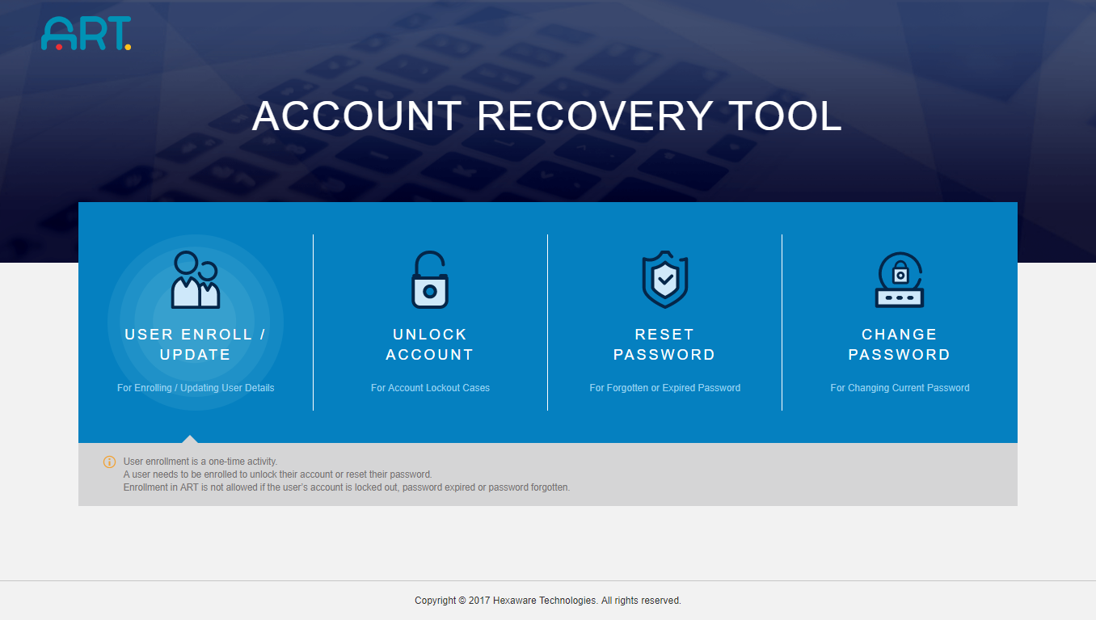

Image 1: Account Recovery Tool Self-Service Portal

The ART Self-Service Portal offers the following 4 options to its users.

## 2.1 User Enroll / Update: For Enrolling New Users and Updating User Details

User Enrolment is the most important step in the functionality of Account Recovery Tool portal. It is a three-step process which ensures that the user can avail the full suite of features that A.R.T. has to offer:

### 2.1.1 Authentication

1. Users are asked to log in to the portal using their account id and password.
2. This process has been designed with the objective of storing information relevant to each and every user of the tool and make the process of Self Service of Account Unlock and Password Reset easy for them.

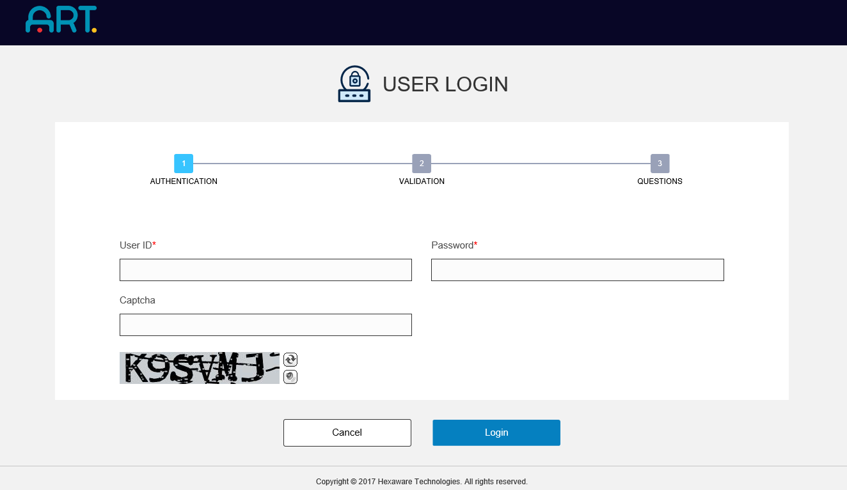

Image 2 Authentication during Enrollment

### 2.1.2 Validation

1. To ensure safety and to take precautions against hacks, a second level of authentication is carried out, generally by enquiring about personal details such as Date of Birth etc. of the users.
2. Here, the users can choose to avail the OTP facility offered by our tool on registering their mobile numbers.

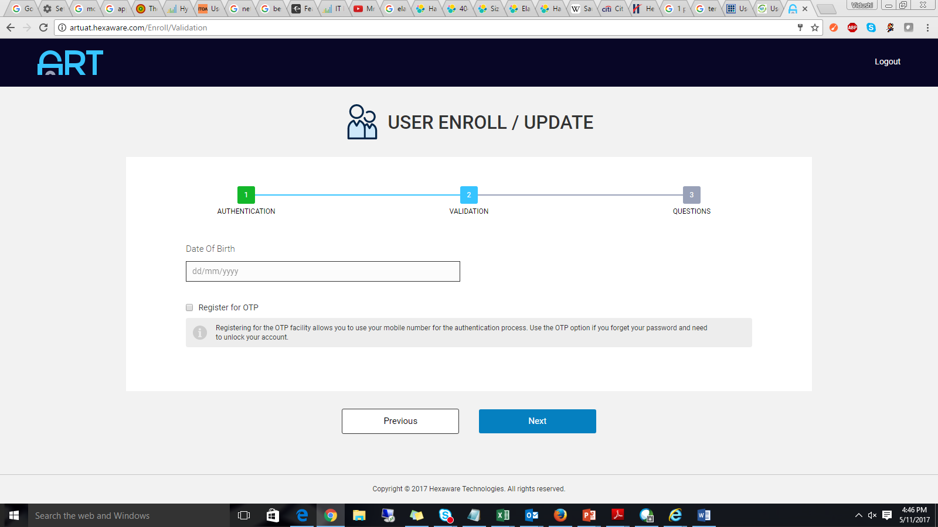

Image 3 Validation of Credentials during Enrollment

1. To provide further security to employees, ART Self-Service Portal also gives the users an option to make their phone numbers private, thus ensuring that their phone number does not get updated in GAL and is also not visible in outlook / skype to users.

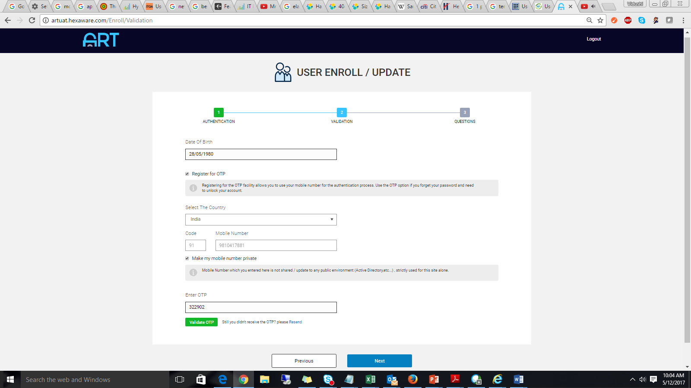

Image 4 Protecting Phone Number option provided by the tool

### 2.1.3 Questionnaire

1. The final step requires the users to answer a wide variety of questions.
2. The answers given by the user will be stored in the tool and used for the purpose of future verification in the event of Unlock Account and Forgot Password.
3. A mismatch in answers will disable this self-service facility for that user.

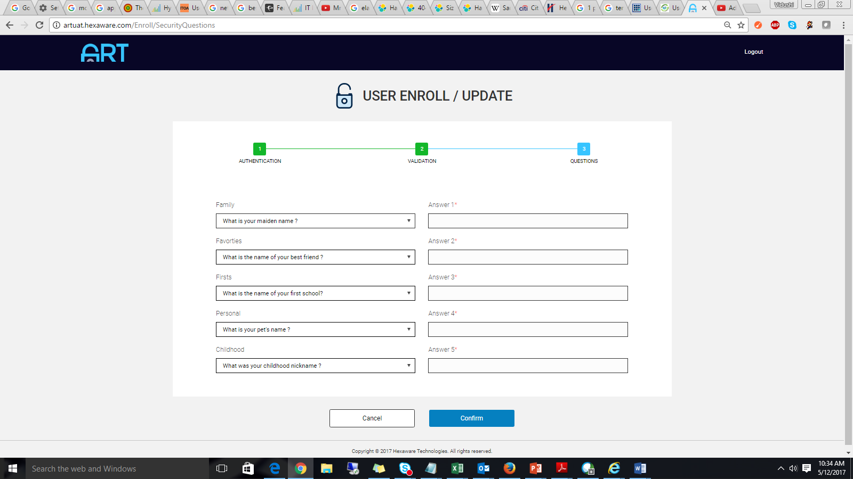

Image 5 Security Questions for future Account Validation attempts

## 2.2 Unlock Account: For Account Lockout Cases

This feature of the ART Self-Service Portal allows the user to avail either the OTP Services or the Security Questions to unlock their locked-out accounts, bypassing the need to call the service desk for assistance.

### 2.2.1 User ID

1. The user is asked to enter their employee id to start the unlock process for their account.
2. When the user chooses this option, a ticket is generated for them concerning the end–to–end functions of this process.

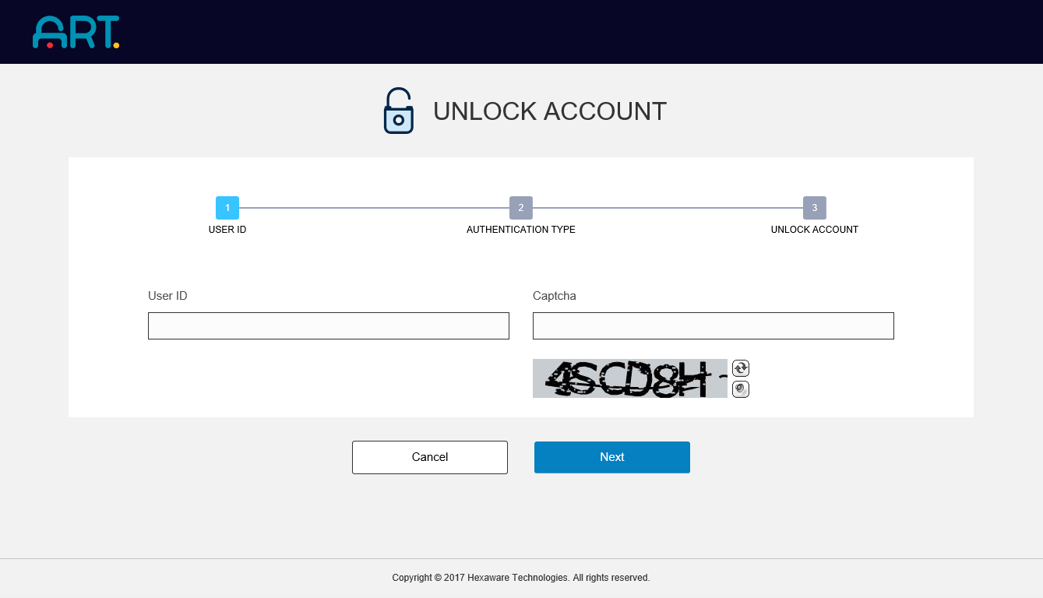

Image 6 Initiating the process of Account Unlock

### 2.2.2 Authentication Type

1. Here, the user can choose an option to unlock their account using either a One Time Password or by answering their security questions.
2. If the former is chosen, the portal will send a One Time Password to the user’s mobile phone for validating their identity. The user can enter the OTP in the given field and unlock their account.
3. If the user chooses the security questions option, they will be asked up to 3 questions and have to answer them correctly to unlock their account.

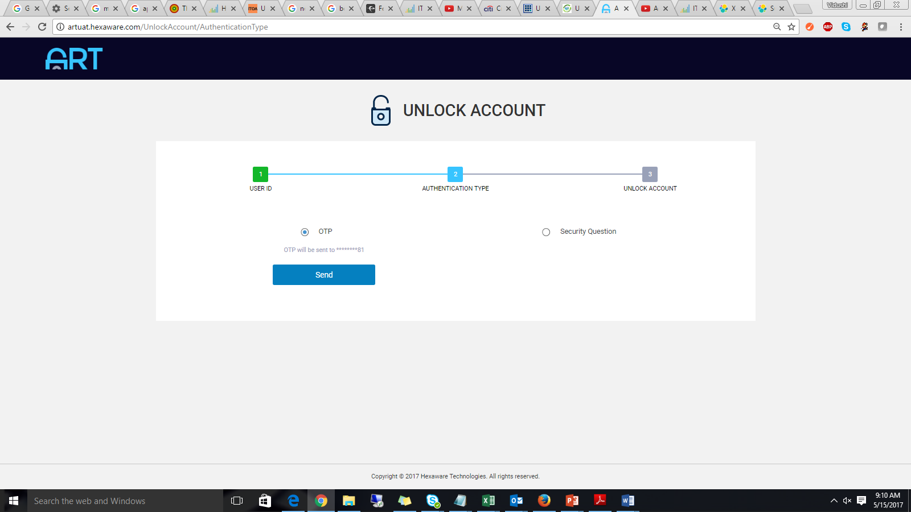

Image 7 Choosing Authentication Type to Unlock Account

### 2.2.3 Unlock Account

1. If the user chooses OTP, an SMS is sent to their registered mobile number to unlock their account.

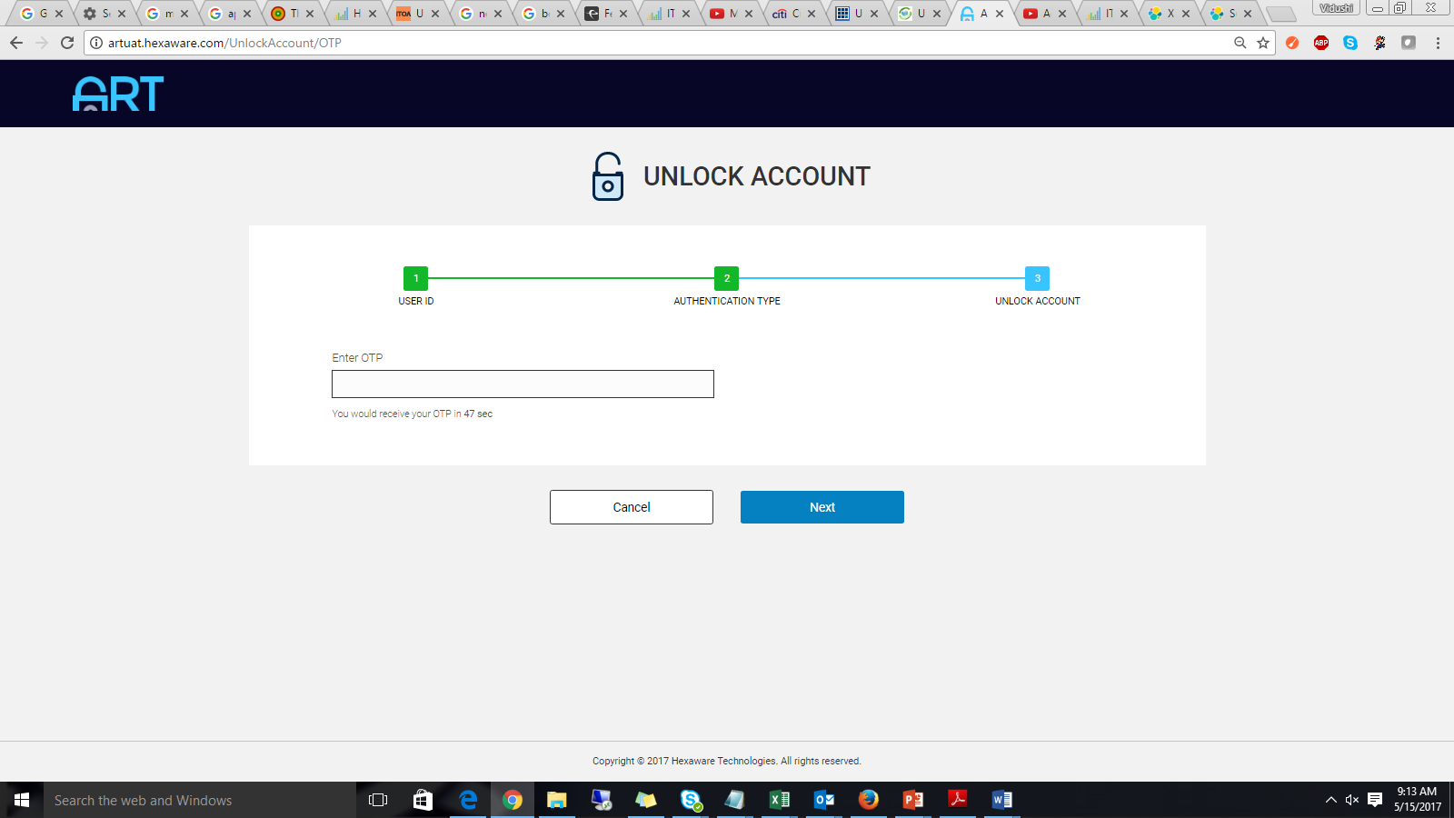

Image 8 Using OTP option to Unlock Account

1. If the user chooses Security Questions, they are asked to answer three questions. If they answer correct, their account gets unlocked.

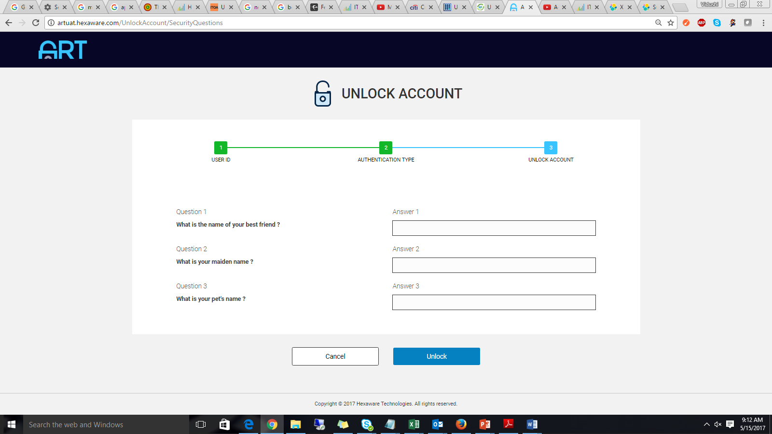

Image 9 Using Security Questions to Unlock Account

## 2.3 Reset Password: For Forgotten or Expired Password Cases

### 2.3.1 User ID

1. The user is asked to enter their employee id to start the process to reset the password to their account.
2. When the user chooses this option, a ticket is generated for them concerning the end–to–end functions of this process.

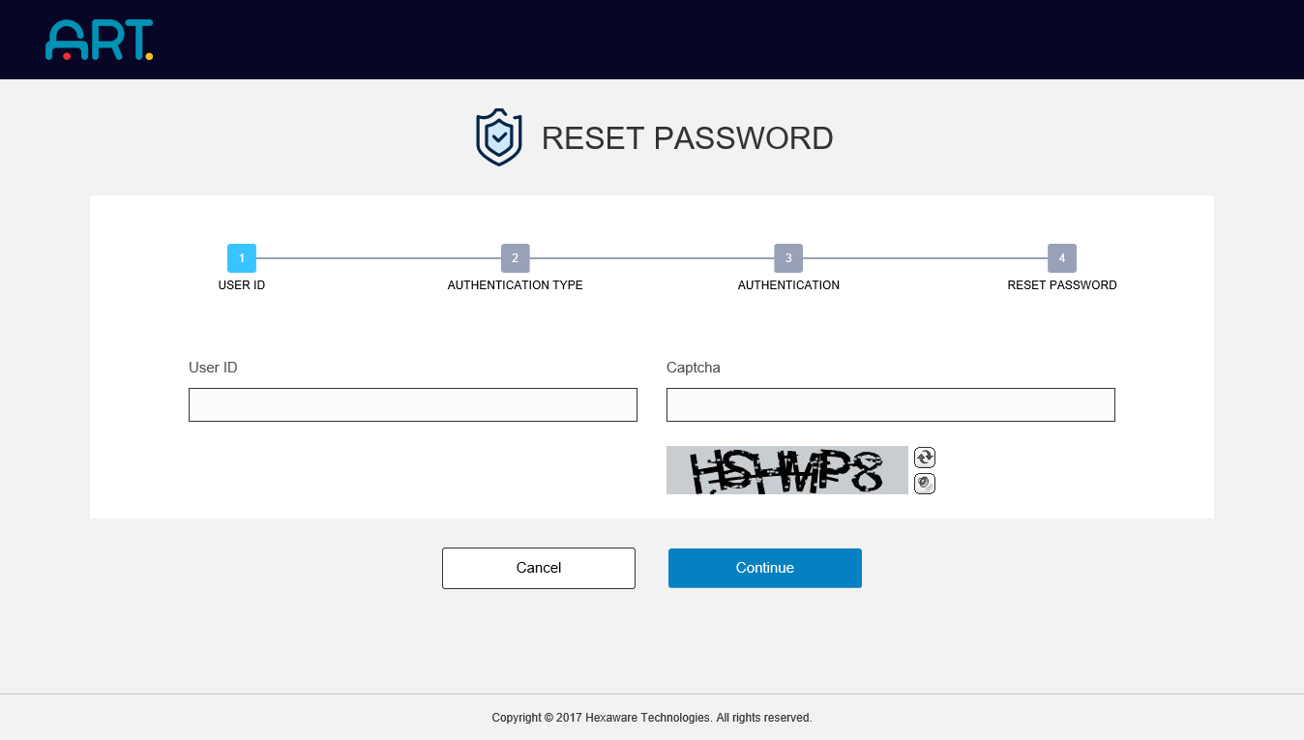

Image 10 Initiating the process of Password Reset

### 2.3.2 Authentication Type

1. Here, the user can choose an option to reset their Account Password using either an OTP sent to their mobile phones or by answering their security questions.
2. If the former is chosen, the portal will send a One Time Password to the user’s mobile phone for validating their identity. The user can enter the OTP in the given field and reset their password.
3. If the user chooses the security questions option, they will be asked up to 3 questions and have to answer them correctly to reset the password to their account.

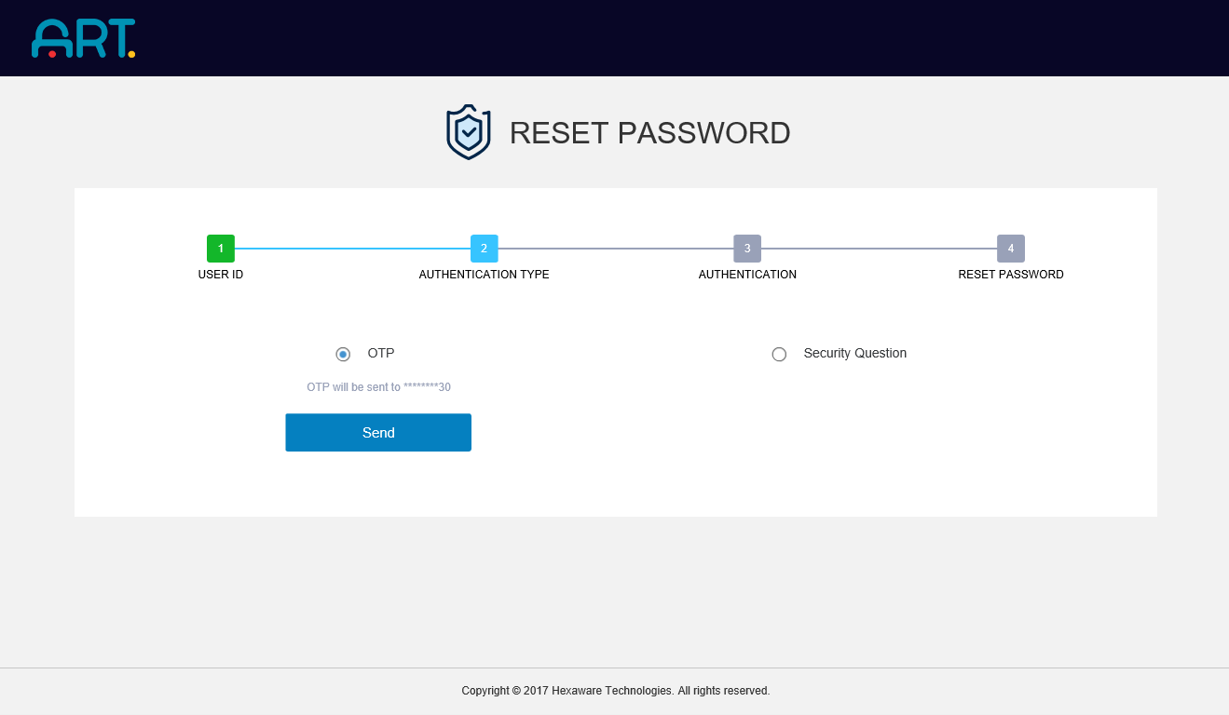

Image 11 Choosing one of the two options to Reset Password

### 2.3.3 Authentication

1. If the user chooses OTP, an SMS is sent to their registered mobile number.

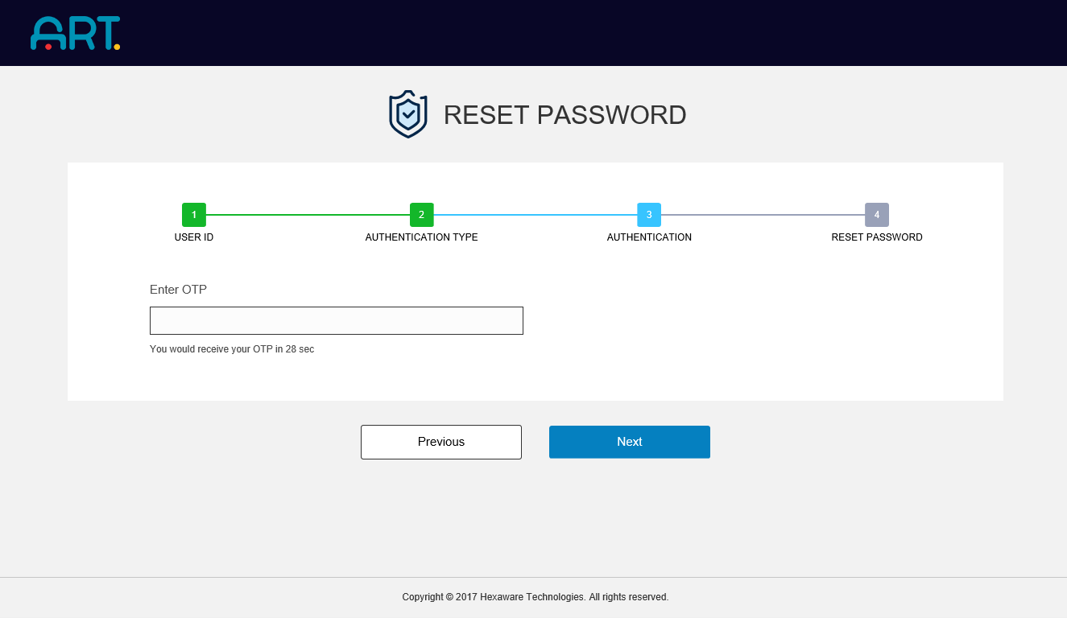

Image 12 Using OTP to Reset Password

1. If the user chooses Security Questions, they are asked to answer three questions. If they answer correct, they move on to the next step.

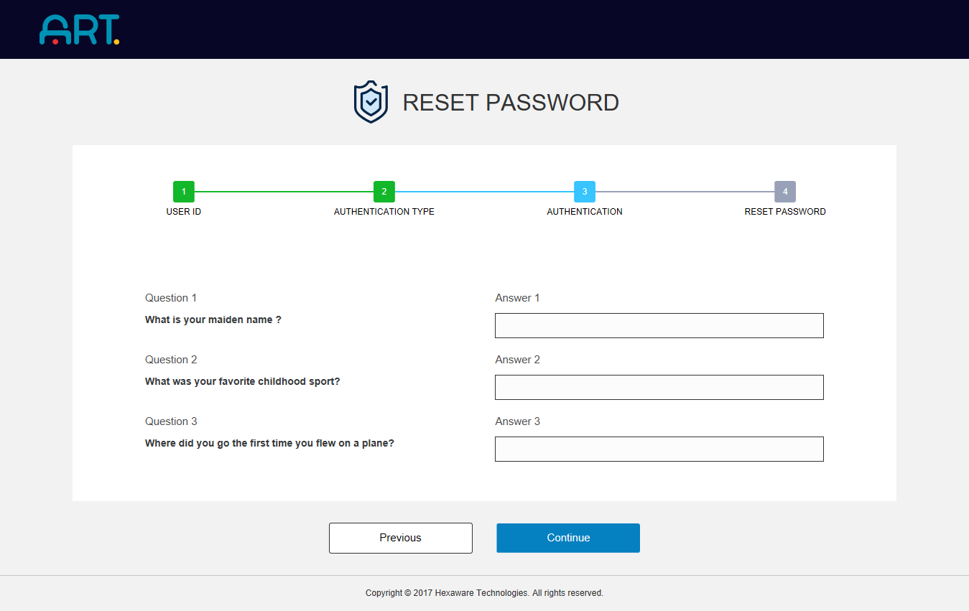

Image 13 Using Security Questions to Reset Password

### 2.3.4 Reset Password

1. In the last step, the user who has received an OTP is asked to validate their OTP and reset their password.
2. The user who on answering their security questions correctly are then allowed to reset their password.
3. As per the company policy, the history of passwords kept by a user will be referred to during the password reset process. The users will not be allowed to keep a password which may match one of their last 7 passwords.

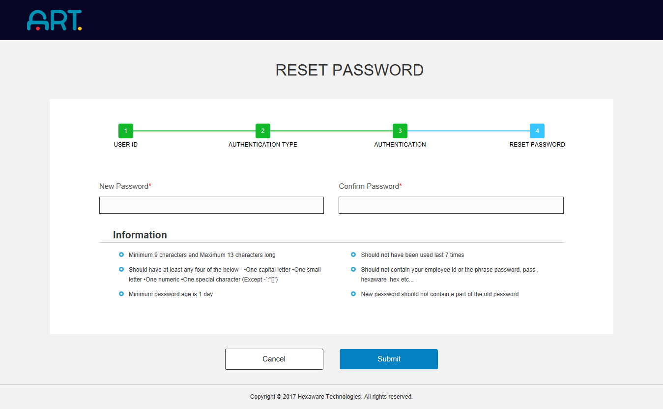

Image 14 Performing Password Reset after successfully validating the User Account

## 2.4 Change Password: For Changing Current Passwords

1. The Change Password option allows the users to change their passwords while they remember their old Password.
2. The users are requested to enter their old password and a Captcha text. On filling all fields correctly, the users are able to change their existing password to a new one.
3. As per the company policy, the history of passwords kept by a user will be referred to during the password reset process. The user will not be allowed to keep a password which may match one of their last 7 passwords.

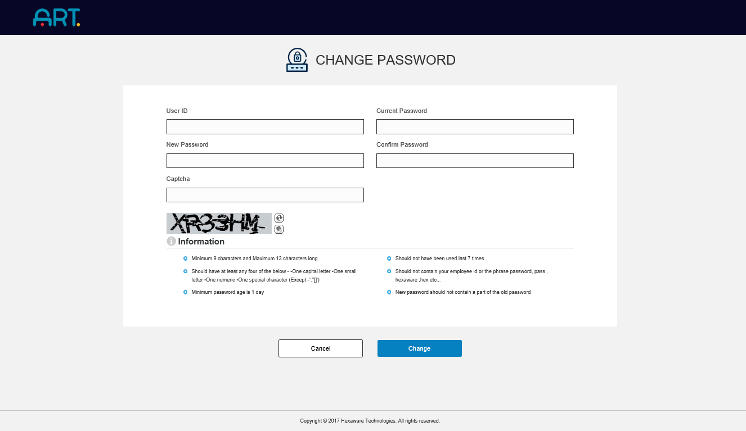

Image 15 Changing Account Password through ART Self-Service Portal

# 3 Advantages

Some advantages of using the ART Self-Service Portal are:

1. End-to-end encryption of data limits the risk of social hacks throughout the process
2. Provides an easy to use web interface to allow users to manage their passwords.
3. Seamless integration with Genie+ (ITSM tools) enabling easy tracking of ticket flows.
4. Allows for SMS/OTP based account verification making it easy to access and validate user identities.

# 4 Support

Please reach out to GSD at 51555 or [GSD_STG@Hexaware.com](mailto:GSD_STG@Hexaware.com) for further support on any of the above features.